**High Level Design & Low-Level Design**

**Document Control:**

Project Database History

|  |  |  |  |  |
| --- | --- | --- | --- | --- |
| **Date** | **Product Name** | **Supplier Name** | **Description** | **Approver**  **Signature** |
| 19.11.2022 | Sofa | SD Furniture Store |  |  |
|  |  |  |  |  |
|  |  |  |  |  |

**Index**

1. **Introduction —-------------------------------- 4**

1.1Intended audience —-------------------------------------- 4

1.2 Project purpose —-------------------------------------- 4

1.3 Key project objective —-------------------------------------- 4

1.4 Project scope —-------------------------------------- 4

1.5 Functional overview —-------------------------------------- 4

1.5.1 Header files —-------------------------------------- 4

1.5.2 Functions —-------------------------------------- 5

1. **Design Overview —-------------------------------- 11**

2.1Design objective **—--------------------------------** 11

2.2 Design alternative —-------------------------------- 11

2.3 User interface Paradigms —-------------------------------- 12

2.4 Validations —-------------------------------- 12

1. **Detailed System Design —-------------------------------- 13**

3.1 Flow Chart **—--------------------------------------** 13

3.2 DFD of Level 0 —---—-------------------------------- 14

3.3 DFD of Level 1 —---—-------------------------------- 14

1. **UML Diagram —-------------------------------- 15**

4.1 Use Case Diagram —---**—--------------------------------** 15

4.2 Sequence Diagram —---—-------------------------------- 16

4.3 Class Diagram —---—-------------------------------- 17

4.4 Er Diagram ----------------------------------------- 18

1. **Environment description —-------------------------------- 18**

5.1 Time zone support —--------**-------------**----------------- 18

5.2 Language support —---—-------------------------------- 18

5.3 User desktop requirement —---—-------------------------------- 18

5.4 Server-side requirements —-------------------------------------- 18

5.4.1 Deployment consideration —---------------------------------------18

5.4.2 Database server disk space —-----—-------------------------------18

5.4.3 Integration requirements —-----**—------------------------------** 18

5.5 Configuration —-------------------------------- 19

5.5.1 Operating System **—--------------------------------** 19

1. Introduction: -

**1.1 Intended Audience: -**

The audience set for this project would include admin who handles the system, suppliers are the vendors that provide products and customer is the one who will purchase furniture through online.

1.2 Project Purpose: -

The online Furniture ordering system is specially designed for online ordering products with facilities of order placing, creating account, bill generation etc. Secondly, the application also allows only the authorised employee to maintain the supplier, maintain customer and maintain the product. The system also allows employees to order 3 items, transactions done by the customer, Whereas the customer and supplier use this system to create an account, edit and view the details.

1.3 Key Project Objectives: -

1. Allow the customer and supplier to login into the portal.
2. The application allows the customer to place the order.
3. The application allows the customer to order a maximum of 3 products.
4. The system will display the bill to the customer and the admin.
5. Allows the supplier to add and remove the product.
6. A stock database is maintained for all the products.
7. Admin can access both customer and supplier data.

1.4 Project scope: -

This application can be implemented in any online furniture ordering store in the locality which can accept orders 24/7.We can add a home delivery feature which will make our project more flexible with the help of our system, the customer can easily purchase the items without any delay.

**1.5 Functional Overview: -**

1.5.1 Following header files are included in the program:

1. #include <stdio.h>
2. #include <stdlib.h>
3. #include <vector>
4. #include <string>
5. #include <list>
6. #include <limits>

1.5.2 Following functions are included in the program:

**1. Admin Module**: The admin module is one of the main components of the Online furniture Ordering system. Admin will have login details and after entering the login details he/she can access the features. Admin module provides the following features:

* **edit_supplier**(): Admin can edit the details of any supplier like their Name, mobile number, and address.
* **remove_supplier():** Admin can remove any supplier from the list.
* **view_supplier_list():** Admin can view the list of all the suppliers.
* **edit_customer():** Admin can edit the details of any customer like their Name, mobile number, and address.
* **remove_customer():** Admin can remove any customer from the list.
* **view_customer_list():** Admin can view the list of all the customers.
* **add product():** Admin can add the product to any supplier by entering the supplier ID.
* **edit_product():** Admin can edit the details of any product by entering the product ID.
* **remove_product():** Admin can remove any product by entering the product ID.
* **view_product_list():** Admin can view the list of all the products.
* **top_3_product ():** Admin can view the top 3 sold products.
* **order_stock():** If the stock is out of range, then the admin can order the stock.
* **stock_report():**  In this function, it will display the total stock.
* **view_transactions():** Admin can view transaction reports on a daily basis.

**2. Supplier Module:** A supplier module is one of the main modules of the Online furniture Ordering system which provides the following features:

* **register_supplier():** The supplier can register by providing his/her basic info like name, address, or Mobile no. etc on our furniture Ordering System**.**
* **login_supplier():** The supplier can log in using the supplier Id and can access the supplier features.
* **edit_supplier_details():** The supplier can edit his basic info like his name, address, or mobile no. etc and it will get updated into the supplier database.
* **view_supplier():** The supplier can view the details entered by him.
* **products_supplied():** This function will give the product which is supplied to the customer.
* **add_product():** Supplier can add the product by giving the information like product name, units, cost of each item.
* **edit_product():** The supplier can edit the product after the product is supplied.

**3. Customer Module:** The customer module provides the following features.

* **register_customer():** New customers can register by providing details like Name, address, and mobile number.
* **login_customer():** Customers can log in by entering their customer ID to continue shopping.
* **view_transaction_history():** Customers can view all their previous transactions by this function.
* **edit_customer_details():** Customers can edit their details like Name, mobile number, and details.
* **view_items():** The customer can view all the items which are supplied by the supplier and can order from them.
* **place_order():** The customer can place an order by entering the product ID and the units he wants to purchase. After placing the order, a bill will be generated.
* **view_customer():** The customer can view the details of himself.

Online furniture Ordering System comprises three modules and the following member functions:

|  |  |
| --- | --- |
| Name of the Module | Main menu |
| Handled by | Admin |
| Description |  |

|  |  |
| --- | --- |
| Name of the Module | register_customer() |
| Handled by | Customer |
| Description | New customers can register by providing details like Name, address, and mobile number. |

|  |  |
| --- | --- |
| Name of the Module | login_customer() |
| Handled by | Customer |
| Description | Customers can login by entering their customer ID to continue placing furniture order. |

|  |  |
| --- | --- |
| Name of the Module | view_customer() |
| Handled by | Customer |
| Description | The customer can view the details of himself. |

|  |  |
| --- | --- |
| Name of the Module | edit_customer_details() |
| Handled by | Customer |
| Description | Customers can edit their details like Name, mobile number, and details. |

|  |  |
| --- | --- |
| Name of the Module | view_items() |
| Handled by | Customer |
| Description | Customers can view all the items which are supplied by the supplier and can order from them. |

|  |  |
| --- | --- |
| Name of the Module | place_order() |
| Handled by | Customer |
| Description | The customer can place an order by entering the product ID and no of units he wants to purchase. After placing the order, a bill will be generated. |

|  |  |
| --- | --- |
| Name of the Module | view_transaction_history() |
| Handled by | Customer |
| Description | Customers can view all their previous transactions by this function. |

|  |  |
| --- | --- |
| Name of the Module | register_supplier() |
| Handled by | Supplier |
| Description | The supplier can register by providing his/her basic info like name, address, Mobile no. etc on our Online furniture Ordering System. |

|  |  |
| --- | --- |
| Name of the Module | login_supplier() |
| Handled by | Supplier |
| Description | The supplier can login using the supplier Id and can access the supplier features. |

|  |  |
| --- | --- |
| Name of the Module | edit_supplier_details() |
| Handled by | Supplier |
| Description | The supplier can edit his basic info like his name, address, or mobile no. etc and it will get updated into the supplier database. |

|  |  |
| --- | --- |
| Name of the Module | view_supplier() |
| Handled by | Supplier |
| Description | The supplier can view the details entered by him. |

|  |  |
| --- | --- |
| Name of the Module | products_supplied() |
| Handled by | Supplier |
| Description | This function will give the product which is supplied to the customer. |

|  |  |
| --- | --- |
| Name of the Module | add_product() |
| Handled by | Supplier |
| Description | Suppliers can add the product by giving information like product name, units, and cost of each item. |

|  |  |
| --- | --- |
| Name of the Module | edit_product() |
| Handled by | Supplier |
| Description | Suppliers can edit the product after the product is supplied. |

|  |  |
| --- | --- |
| Name of the Module | remove_supplier() |
| Handled by | Admin |
| Description | Admin can remove any supplier from the list. |

|  |  |
| --- | --- |
| Name of the Module | remove_customer() |
| Handled by | Admin |
| Description | Admin can remove any customer from the list. |

|  |  |
| --- | --- |
| Name of the Module | remove_product() |
| Handled by | Admin |
| Description | Admin can remove any product by entering the product ID. |

|  |  |
| --- | --- |
| Name of the Module | view_supplier_list() |
| Handled by | Admin |
| Description | Admin can view the list of all the suppliers. |

|  |  |
| --- | --- |
| Name of the Module | view_customer_list() |
| Handled by | Admin |
| Description | Admin can view the list of all the customers. |

|  |  |
| --- | --- |
| Name of the Module | view_product_list() |
| Handled by | Admin |
| Description | Admin can view the list of all the products. |

|  |  |
| --- | --- |
| Name of the Module | view_transactions() |
| Handled by | Admin |
| Description | Admin can view transaction reports on a daily basis. |

|  |  |
| --- | --- |
| Name of the Module | add_product() |
| Handled by | Admin |
| Description | Admin can add the product to any supplier by entering the supplier ID. |

|  |  |
| --- | --- |
| Name of the Module | edit_supplier() |
| Handled by | Admin |
| Description | Admin can edit the details of any supplier like their Name, mobile number, and address. |

|  |  |
| --- | --- |
| Name of the Module | edit_customer() |
| Handled by | Admin |
| Description | Admin can edit the details of any customer like their Name, mobile number, and address. |

|  |  |
| --- | --- |
| Name of the Module | edit_product() |
| Handled by | Admin |
| Description | Admin can edit the details of any product by entering the product ID. |

|  |  |
| --- | --- |
| Name of the Module | order_stock() |
| Handled by | Admin |
| Description | If the stock is out of range, then the admin can order the stock. |

|  |  |
| --- | --- |
| Name of the Module | top_three_product() |
| Handled by | Admin |
| Description | Admin can view the top 3 sold products. |

|  |  |
| --- | --- |
| Name of the Module | stock_report() |
| Handled by | Admin |
| Description | In this function, it will display the total stock. |

**2. Design Overview**

2.1 Design Objectives: -

* Creating a user-friendly Online Furniture Ordering Application.
* Customers will login into the application and view all the items.
* Customers can place an order and view the transaction.
* Products will be supplied by the supplier and if needed, the supplier can add, edit, and view the products.
* Admin maintains both the customer and supplier like remove, view, add or edit.
* The top 3 most sold products can be displayed by the admin.
* The stock report is also generated to view the stock.

2.2 Design Alternative: -

We have used three different structures to store data i.e., supplier ,customer and admin and further typedef are used in the program.

2.3 User Interface Paradigms: -

The project aims to create the development of an Online Furniture Ordering application in which admin, supplier, and customer are the main modules. Where Admin maintains supplier and customer. The product can be managed by the supplier and admin and the customer who acts as an interface, can order the required product and go to the transaction to pay the bill.

2.4 Validations

* In Online Furniture Ordering System main menu, the choice entered must be digits (Id) only.
* The customer_name should be alphabet only and should be between 5-25 characters.
* While entering the customer_address, the address should not start with space and should be between 4-40 characters only.
* Mobile_number should be in digits only with the range of 10.
* The product id and quantity of the product should be in digits only.
* The names of the customer, supplier, admin, and product should be in alphabet only.
* Number of units and cost of the product should be in digits.
* Address should not be blank.
* Admin can log in only if the password is validated.

**3. Detailed System design**

3.1 Flow chart

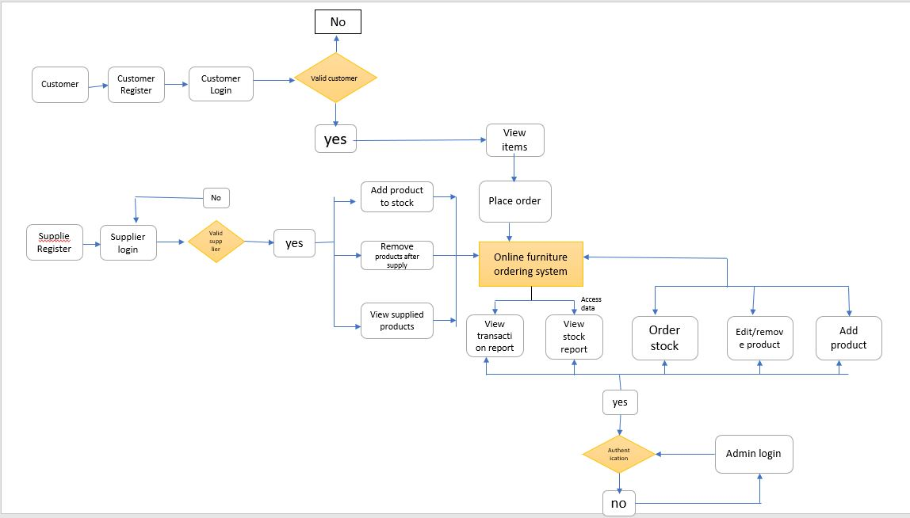

3.2 DFD of Level 0

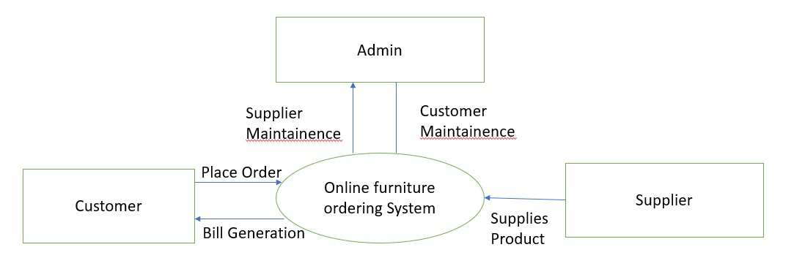

**3.3 DFD of Level 1**

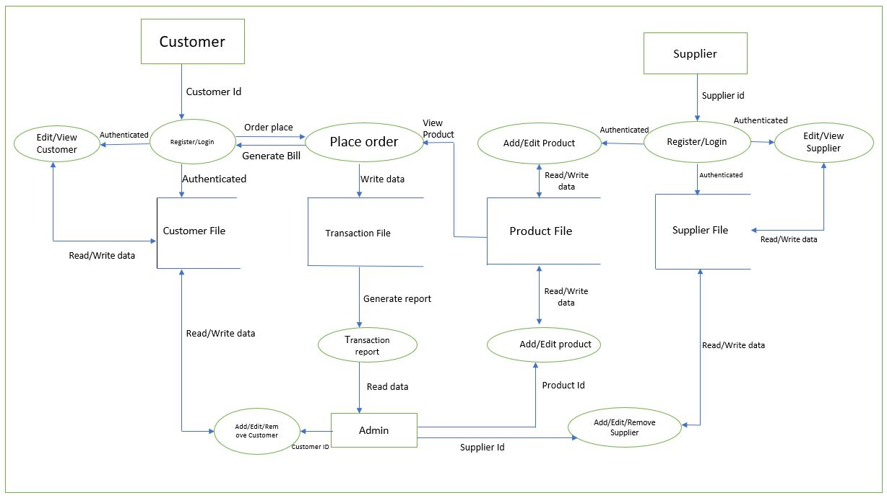

**3. UML Diagrams**

3.1 Use Case Diagram

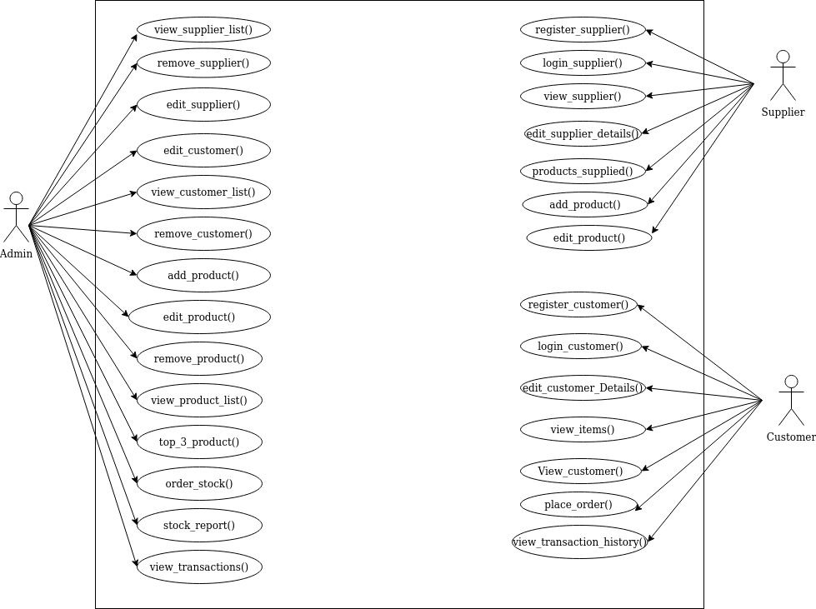

**3.2 Sequence Diagram**

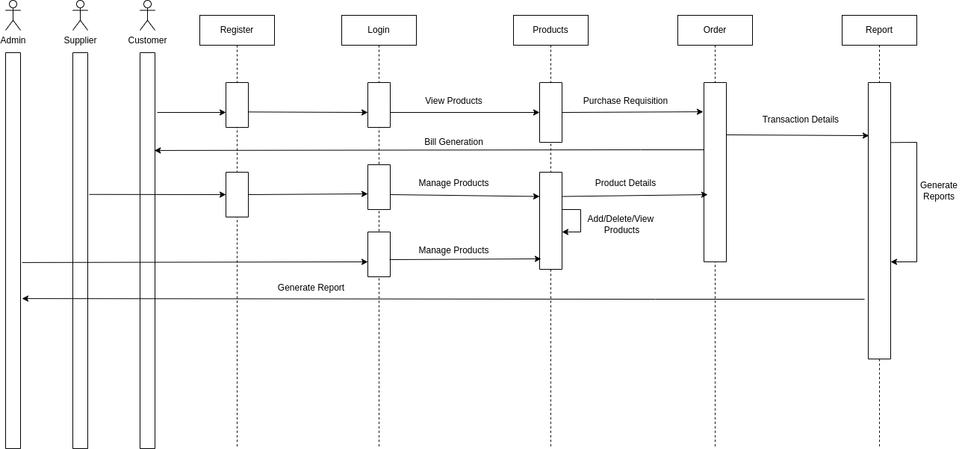

**4.3 Class Diagram**

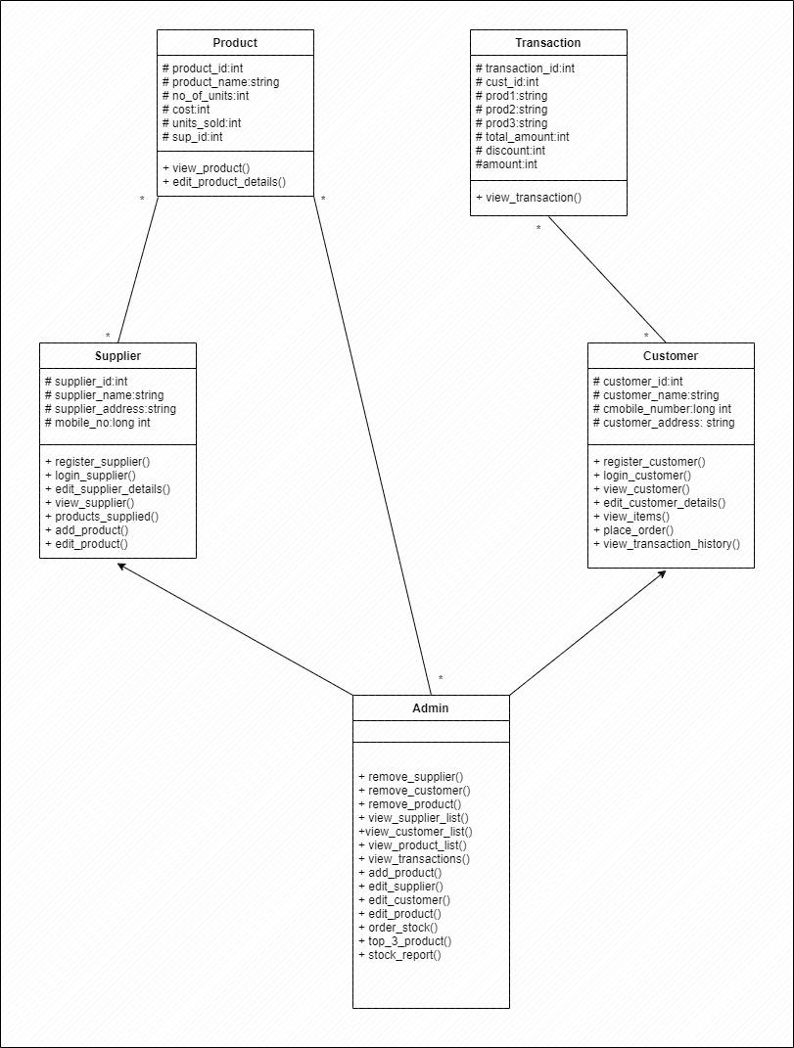

**4.4 ER Diagram**

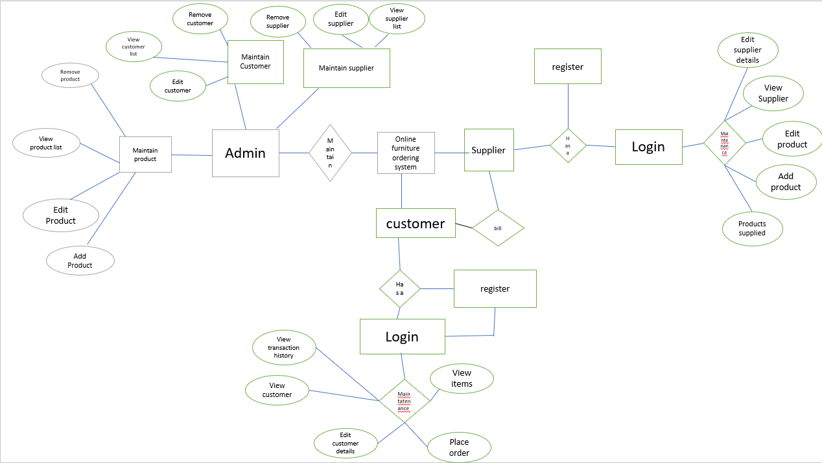

**5. Environment Description**

**5.1 Time zone support -** IST

**5.2 Language Support** - English

**5.3 User Desktop Requirements**-

* 64-bit processor, 1GHz or faster
* At least 2 GB free hard drive space
* At least 1 GB RAM

**5.4 Server-side requirements**

* 32 64-bit processors, 1 GHz or faster
* At least 1 GB free hard drive space
* At least 1GB RAM

**5.4.1. Deployment Considerations: -**

* Easy setup: no session storage daemon, use memory caching to enhance performance.
* Local storage is used
* No network latency to consider

Application Server Disk Space: -

* No such disk space is required as the program is fully functional on online IDE(s) as well. A local Operating System is required and one txt file to store the records of processes.

**5.4.2 Database Server Disk Space: -**

No such disk space is required as the program is fully functional on online IDE(s) as well.

**5.4.3 Integration Requirements: -**

* a. Language: - C
* b. Tools: - Valgrind, makefile,Gcoverage,Gprof
* c. Compiler: gcc
* d. Linux Environment

5.5 Configuration

5.5.1 Operating System - Linux Environment